DE WINTON LOCOMOTIVE

Thank you for buying this Loco kit. Please read all the instructions before assembly.

The first thing to do is to remove the support material and rub down all the parts you are going to paint with sandpaper and a small file in awkward places to get the worst of the grain off. You can use XTC-3D for best results or you can use spray paint from Halfords grey primer or filler primer. Witch ever you use Rub down with 500grit wet and dry. Spray primer and rub down again until you get a smooth finish. Then paint the colour of your choice ( Halfords paint ) .If there is any marks or imperfections rub down again with wet and dry. ( Gloss paint will show this ) then repaint.
When applying rivets at 5mm intervals before the top coat glue the rivets on with liquid poly. When dry paint with primer again and finish with top coat.

CHASSIS
Start off by drilling the four axle holes in the chassis 3.8mm then Fit the four 1/8 brass bearing on the outside of the chassis and glue in places.
Take the two ends and fit 4 2mm nuts inside the slots bolt to the side frames using 4 10mm bolts.
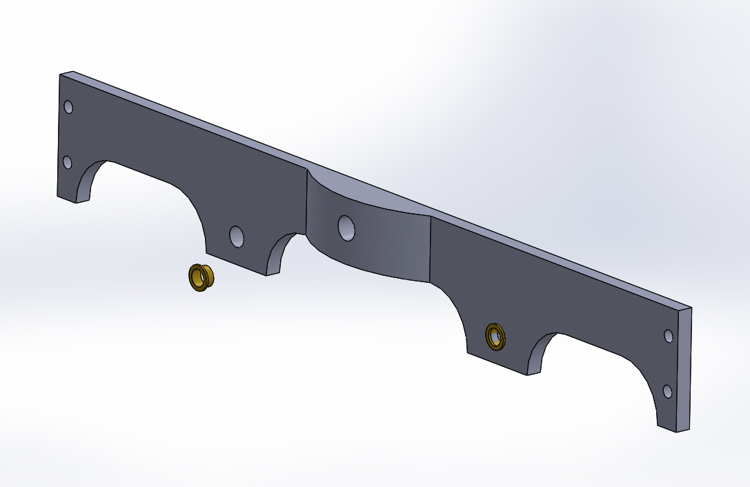
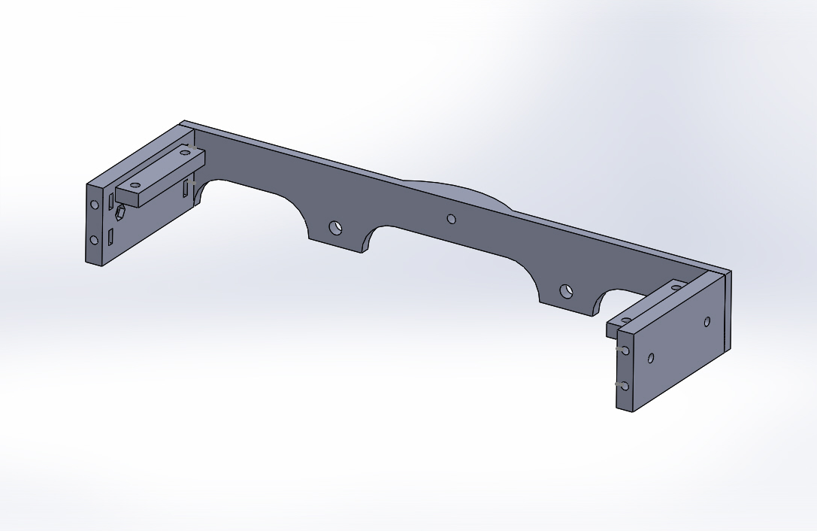

Next take the chassis top and countersunk the 4 outer holes on top and use 4 2mm nuts and 4 2mm x 6mm countersunk bolts to bolt the chassis top on the chassis.

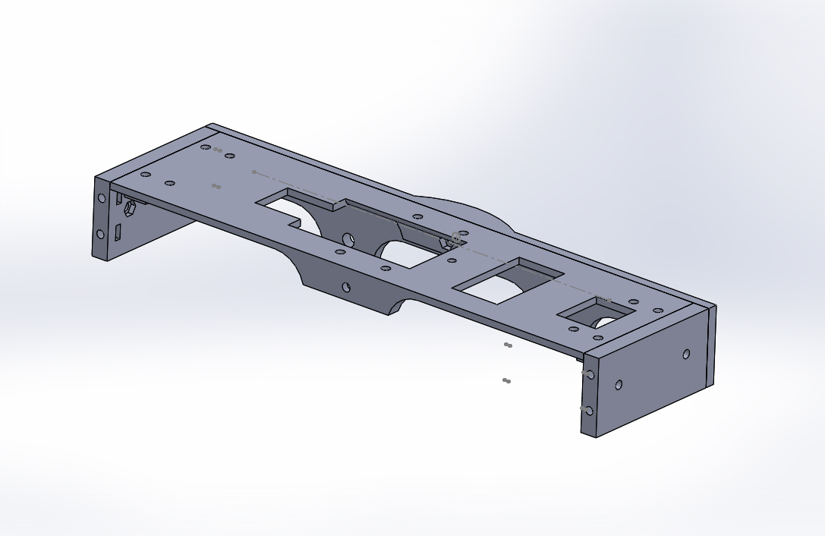

GEARBOX gearbox may be done in some kits

drill the gearbox bearing 4mm push the axle in to the housing fixing each bearing in place with a drop of superglue.
  - Push the motor unit in to the back of the housing, so the gear meshes with the axle one. Insert the 2 x 2.5mm cross-head screws through the housing and into the motor, and loosely tighten them.
  - Oil the bearings and the gears with light engine oil.
  - Test the motor with a low voltage (say 4.5v) initially, to ensure correct meshing of the gears. The slots in the housing allow movement of the motor to get the right meshing of the gears for smooth running.
  - Tighten the 2 cross-head screws – and test again on full operating voltage, in forward and reverse directions.
  - The assembled motor / gearbox / axle unit is then ready to be installed in the model.

Next fit the wheels on the gearbox axle making sure you have equal amount sticking out of both ends should be 11mm sticking out both side. for 45mm gauge is 10mm sticking out both side.
Be very careful not to bend the axle use a vice and a socket and press no.
Next take the sec axle and fit the cam on the centre of the axle there is a hole so you can add a drop of glue inside make sure you have it centre of the axle next fit the two rods that drive the pistons may need to wet and dry till smooth so it can rotate freely.
Now fit the wheels to the axle and making sure you have equal amount on both ends.
Wheel settings for 32mm and 45mm gauge
(32mm gauge 28mm back to back)
(45mm gauge 40mm back to back)

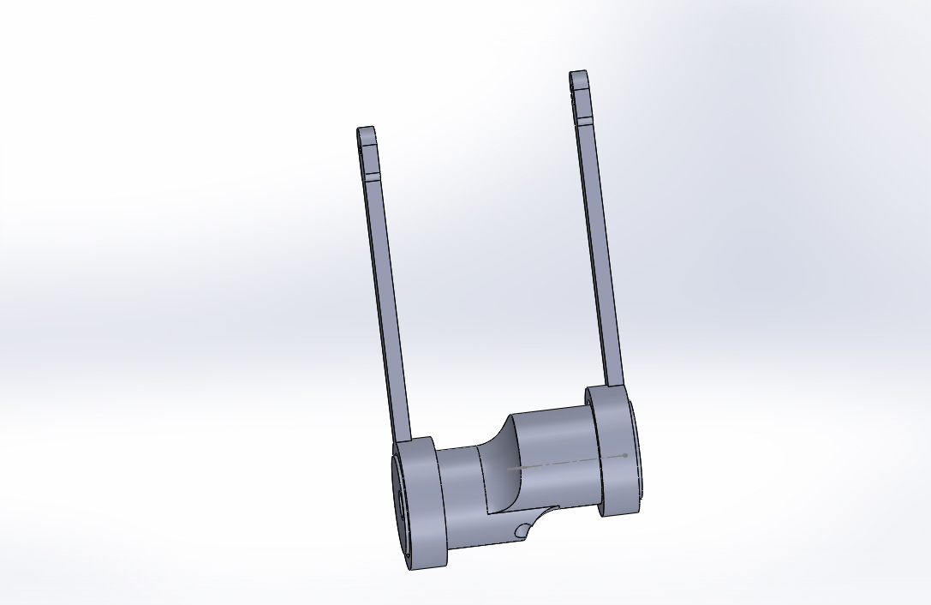

Next take the wheels and fit to the chassis making sure that the wheels with the cranks fits in the hole at the front next fit the side frames as before with 5 10mm bolts make shore the wheels run freely.
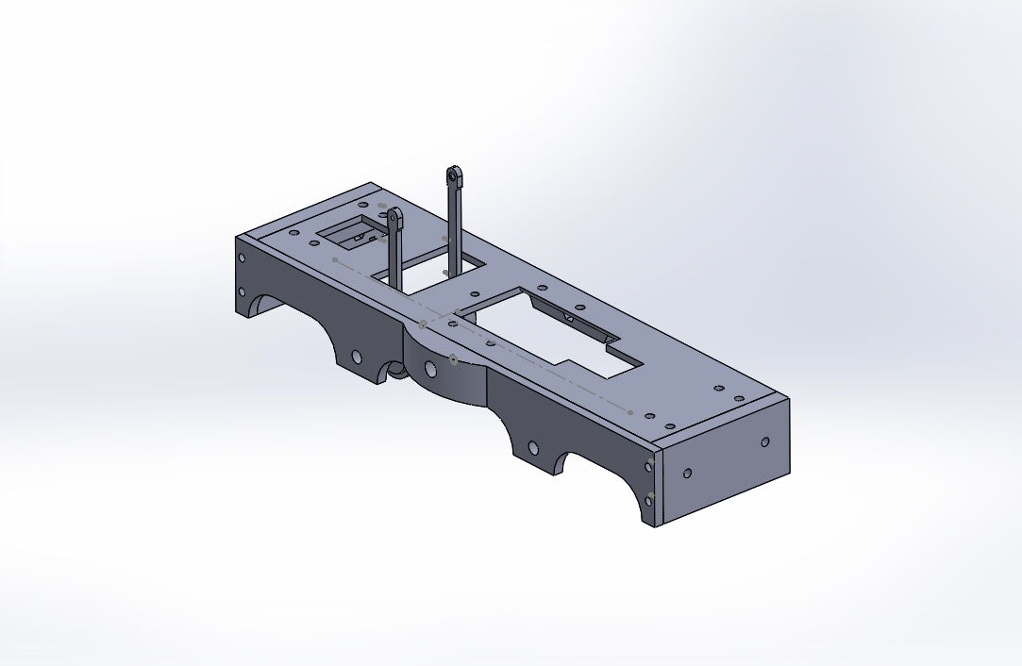

Next take the outside cranks and fit the 2mm x 10 c/s screws making shore you fit the screw from the brass side as this runs up next to the bearing

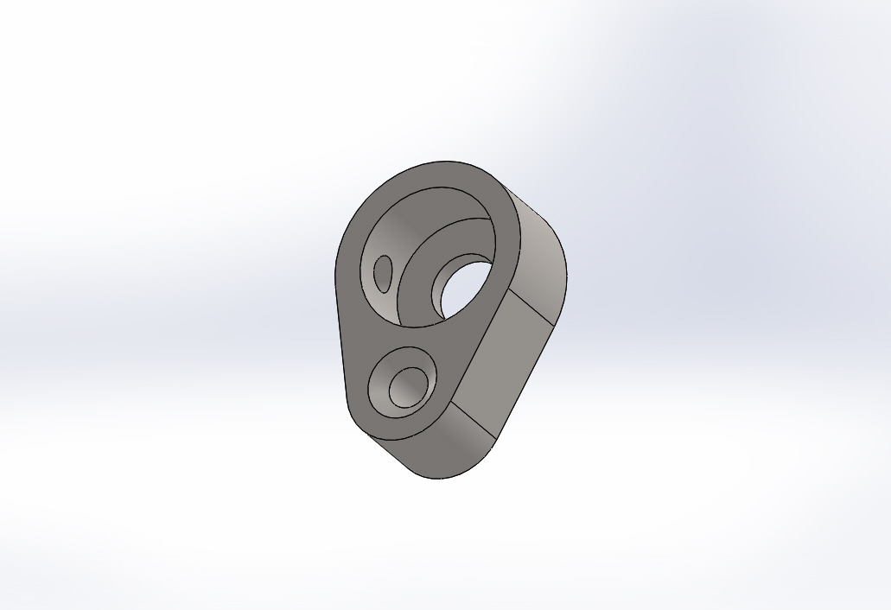

Note the c/s hole

Fit the cranks to the chassis using the 2mm grub screws making shore that the crack pins are 90 decrees from left to right. Take the two steel connecting rods and file the holes so the brass top hats bearings fit loss in side and fit to the cracks with 4 2mm half nuts do not over tighten as need to run free. Ones your happy test run the chassis on low voltage to make shore to runs free

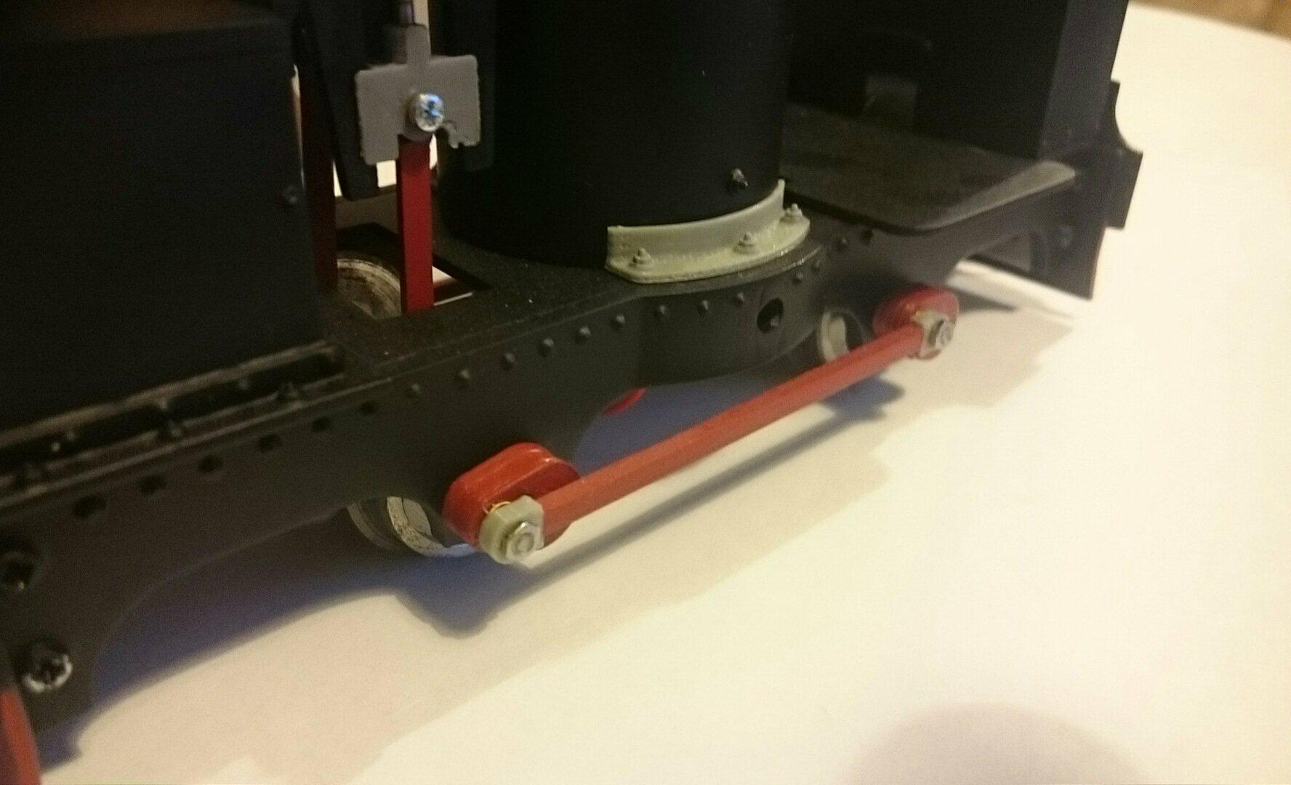

Next fit the foot plate and coal bunker together use two 2mm x 10mm long nuts and bolts then fit the water tank using two 2mm x 10 mm long nuts and bolts.

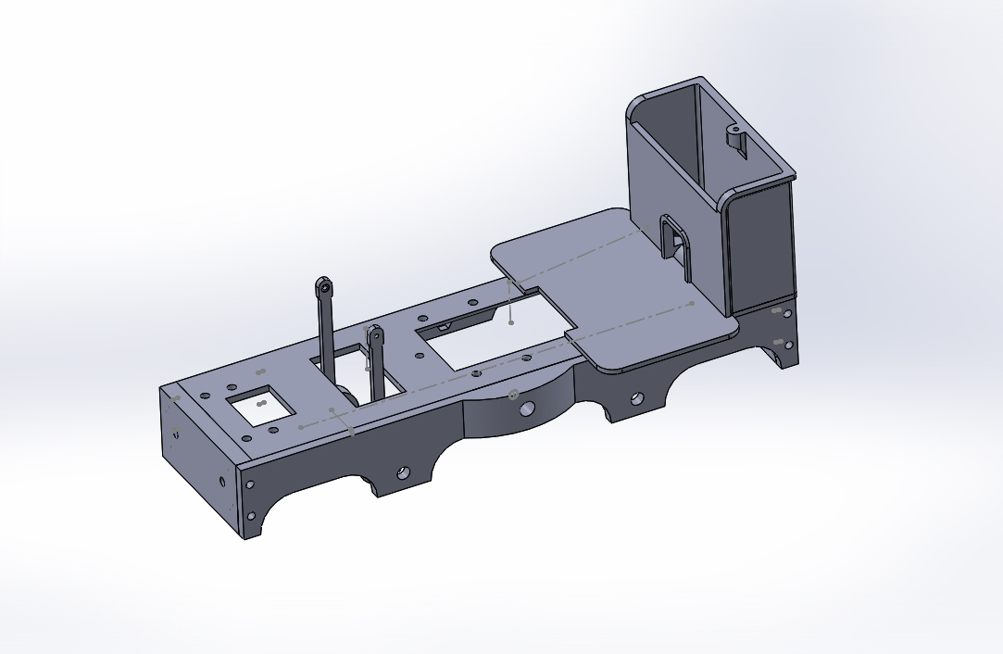
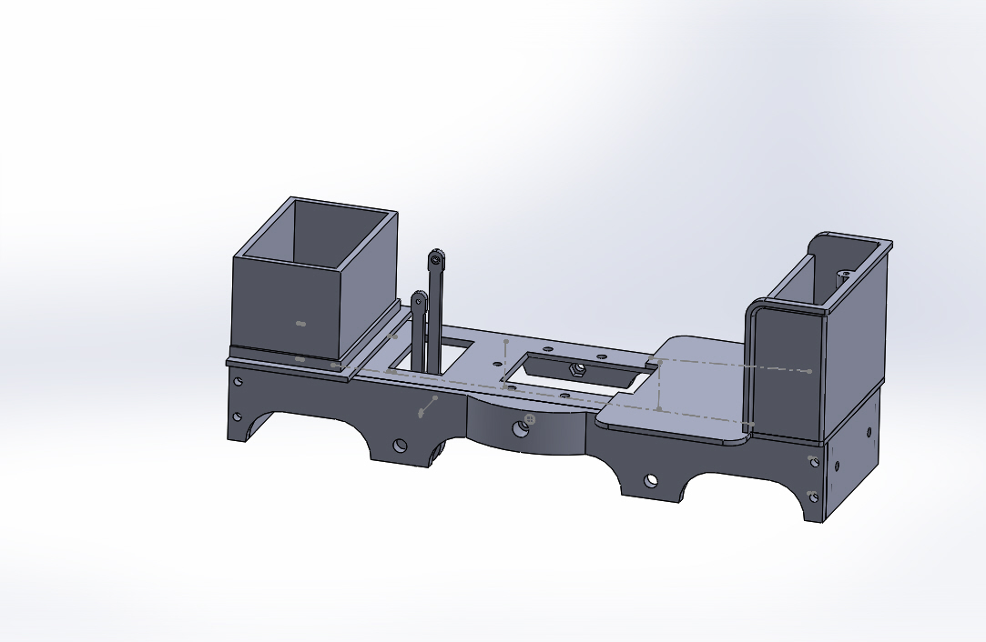

Next take the cylinder block drill out 3mm so you can fit a 3mm brass tube fit with the bottom cylinder cover so I stick out by 1mm do not glue at this time. Take the cross head and fit the 2mm steel rod and glue in places. Take the slide bars and fit to the cylinders make shore you have them the right way round follow pictures below. on the front fit some 1.5mm brass wire about 37mm long in the slide bars . Take the cross head and test fit to make shore it slide freely once happy glue the parts together. Fit the steam in let about half way down see pic below. Next glue on the top cylinder covers.

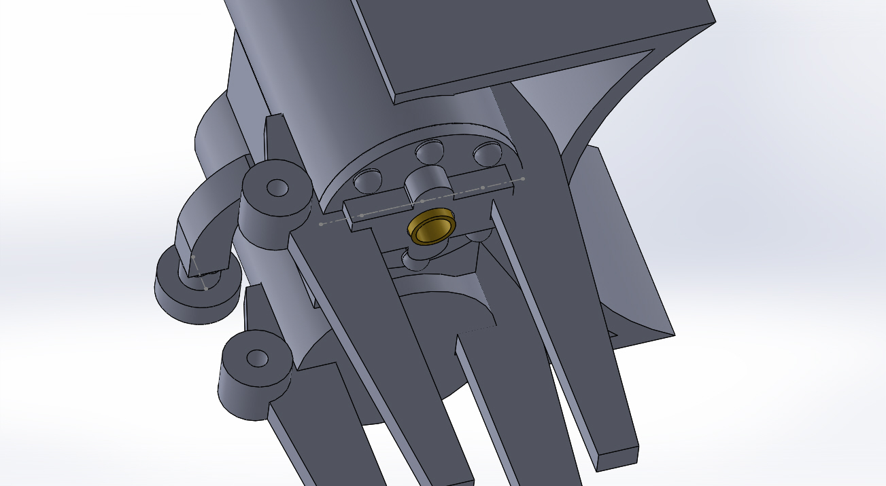
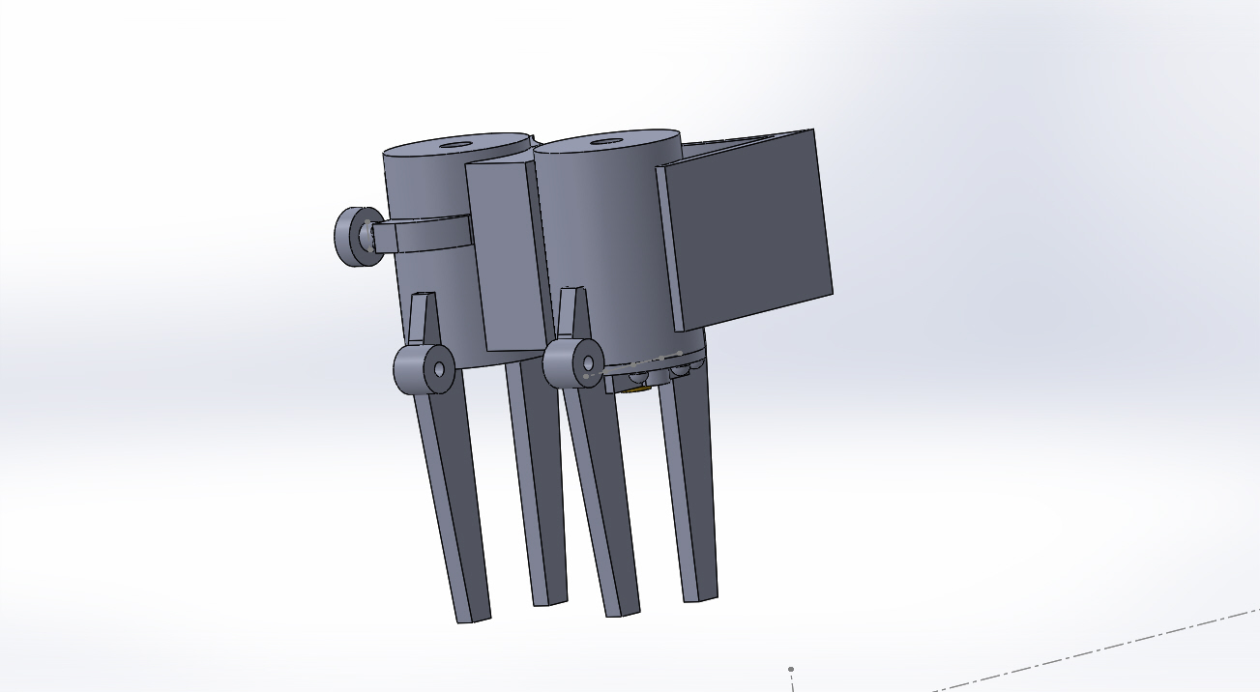

Next take the boiler and fit the cylinders using two 3mm x 8mm cab head bolts

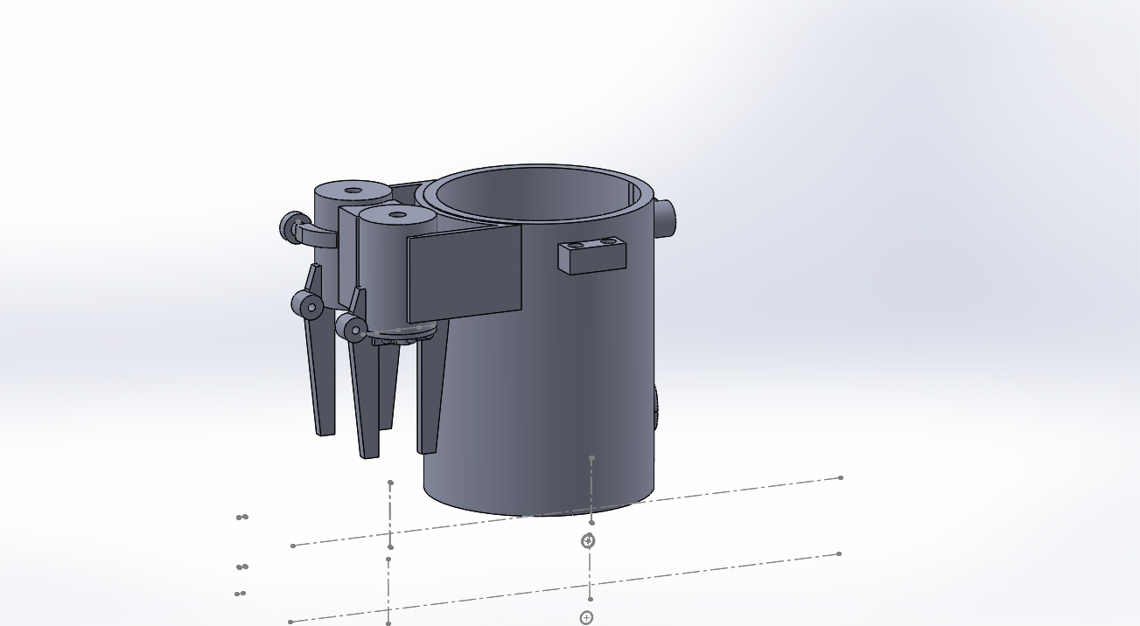

next fit the cross head to the rods on the chassis use 2 mm x 6mm bolt and nuts make sure it can move freely add a dab of glue to hold the nut in place. Next fit the boiler to the chassis slide the rods in to the cylinder at the same time. use 4 2mm x 6mm long nuts and bolts leaving one hole out for later. Take the motor holder the file out till it fits over the motor and fit as the pic below using 1 2mm x 10mm nut and bolt.

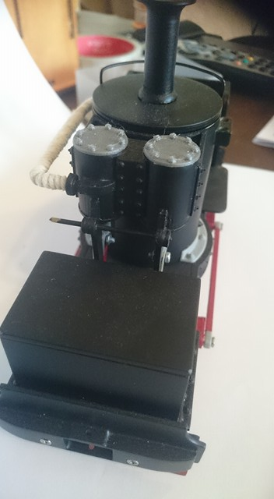
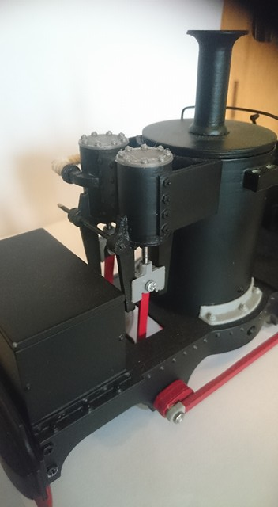

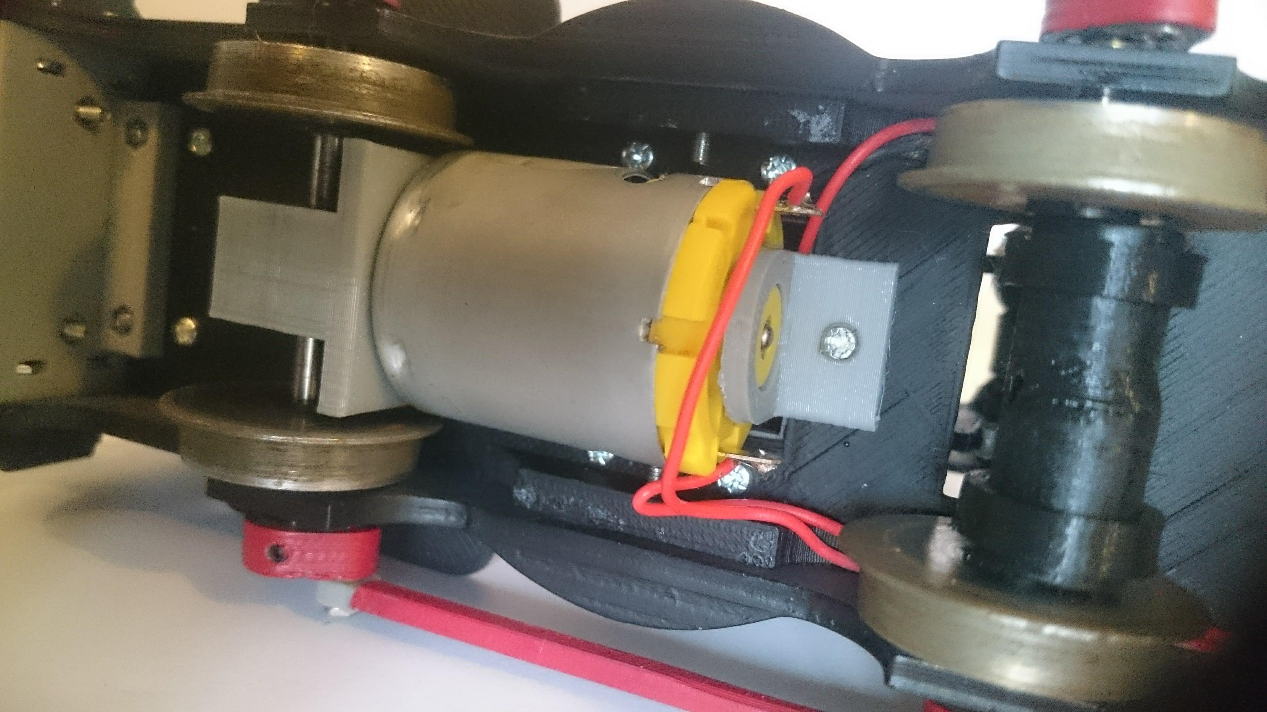

Next fit the 2 part buffer beam as show on the pics below using 4 2mm x 16mm long bolts and nuts

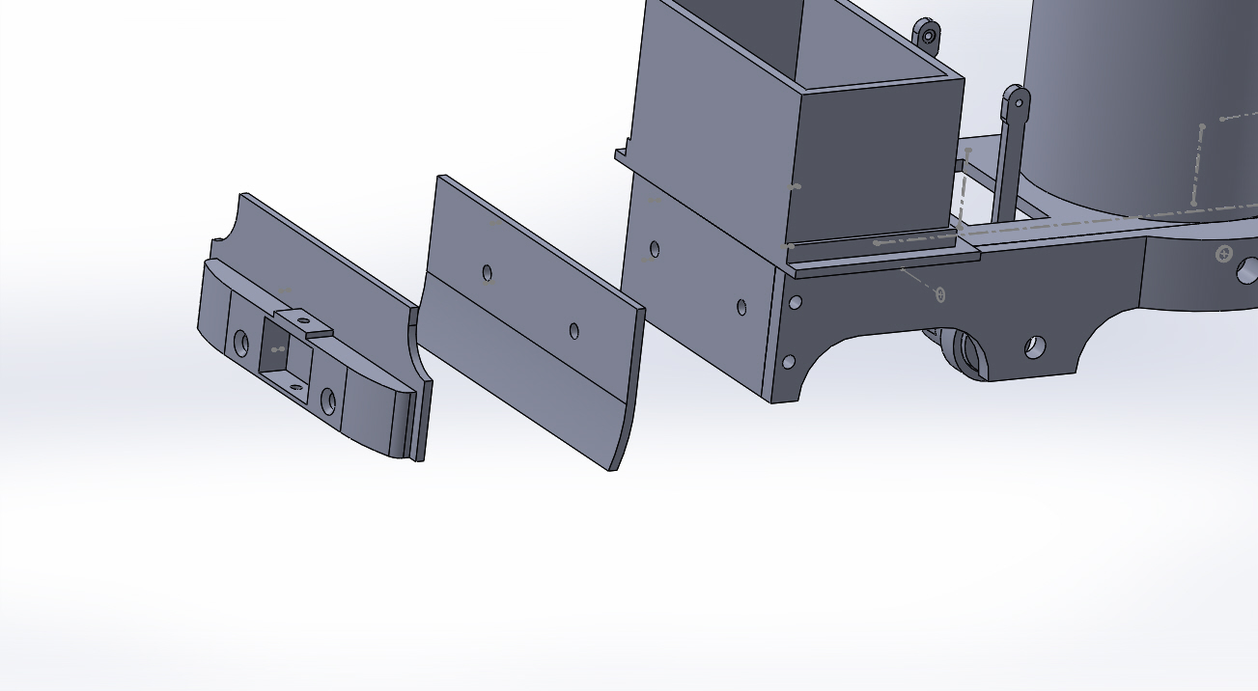
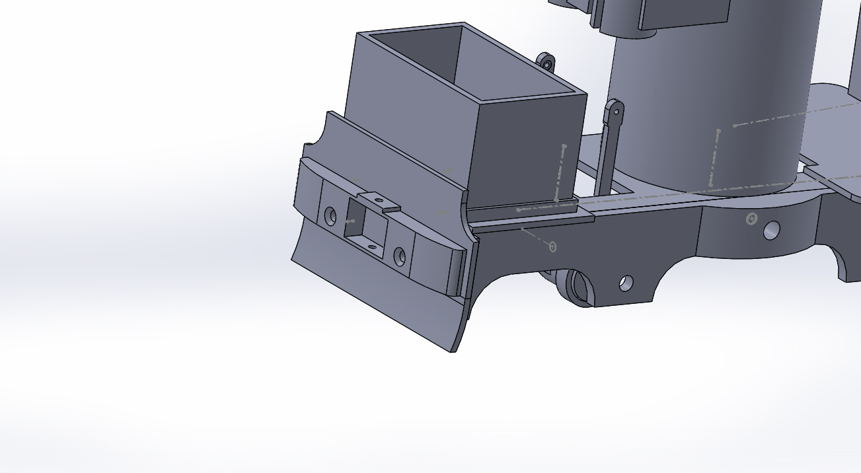

next fit the chimney to the top of the boiler top this need to be removable so you can fit batterers inside later
glue the water tank filler on top of the lid this is a loss fit so you can fit rc gear in side

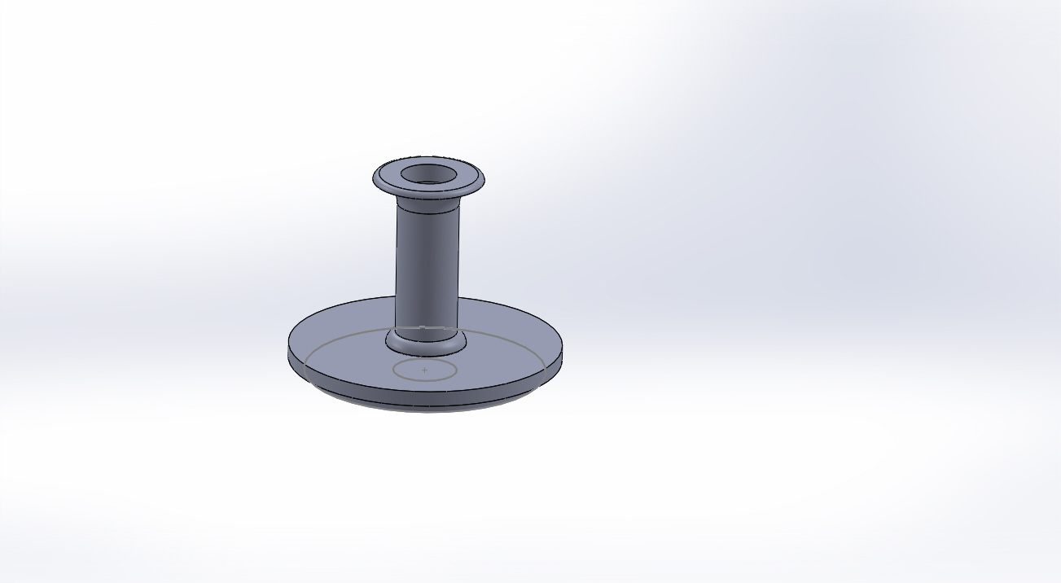
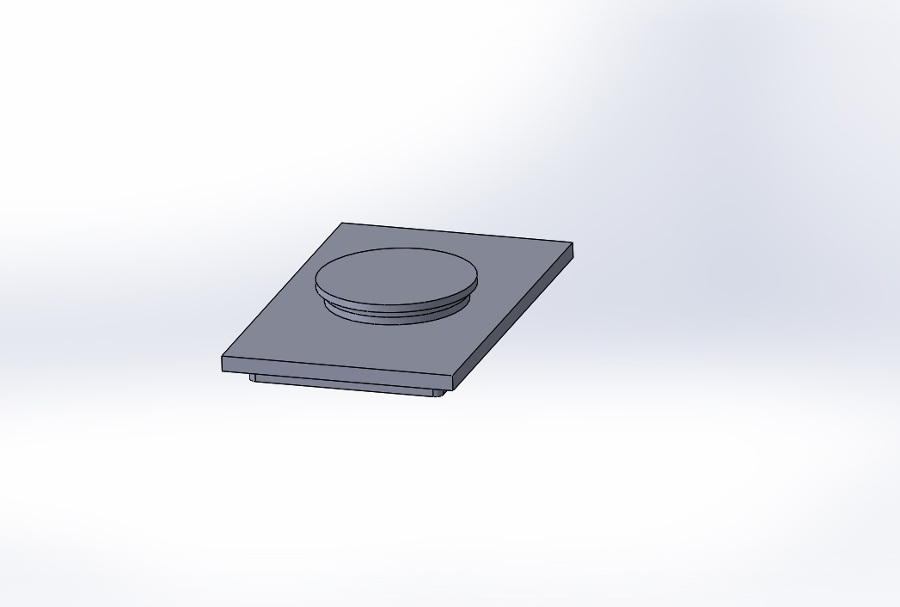

Next glue boiler brackit on the bottom add some nut heads as the pic shown. Make up the pipe from some 1.5mm brass wire to join the regulator to the cylinders rap it is some string and fit to the loco

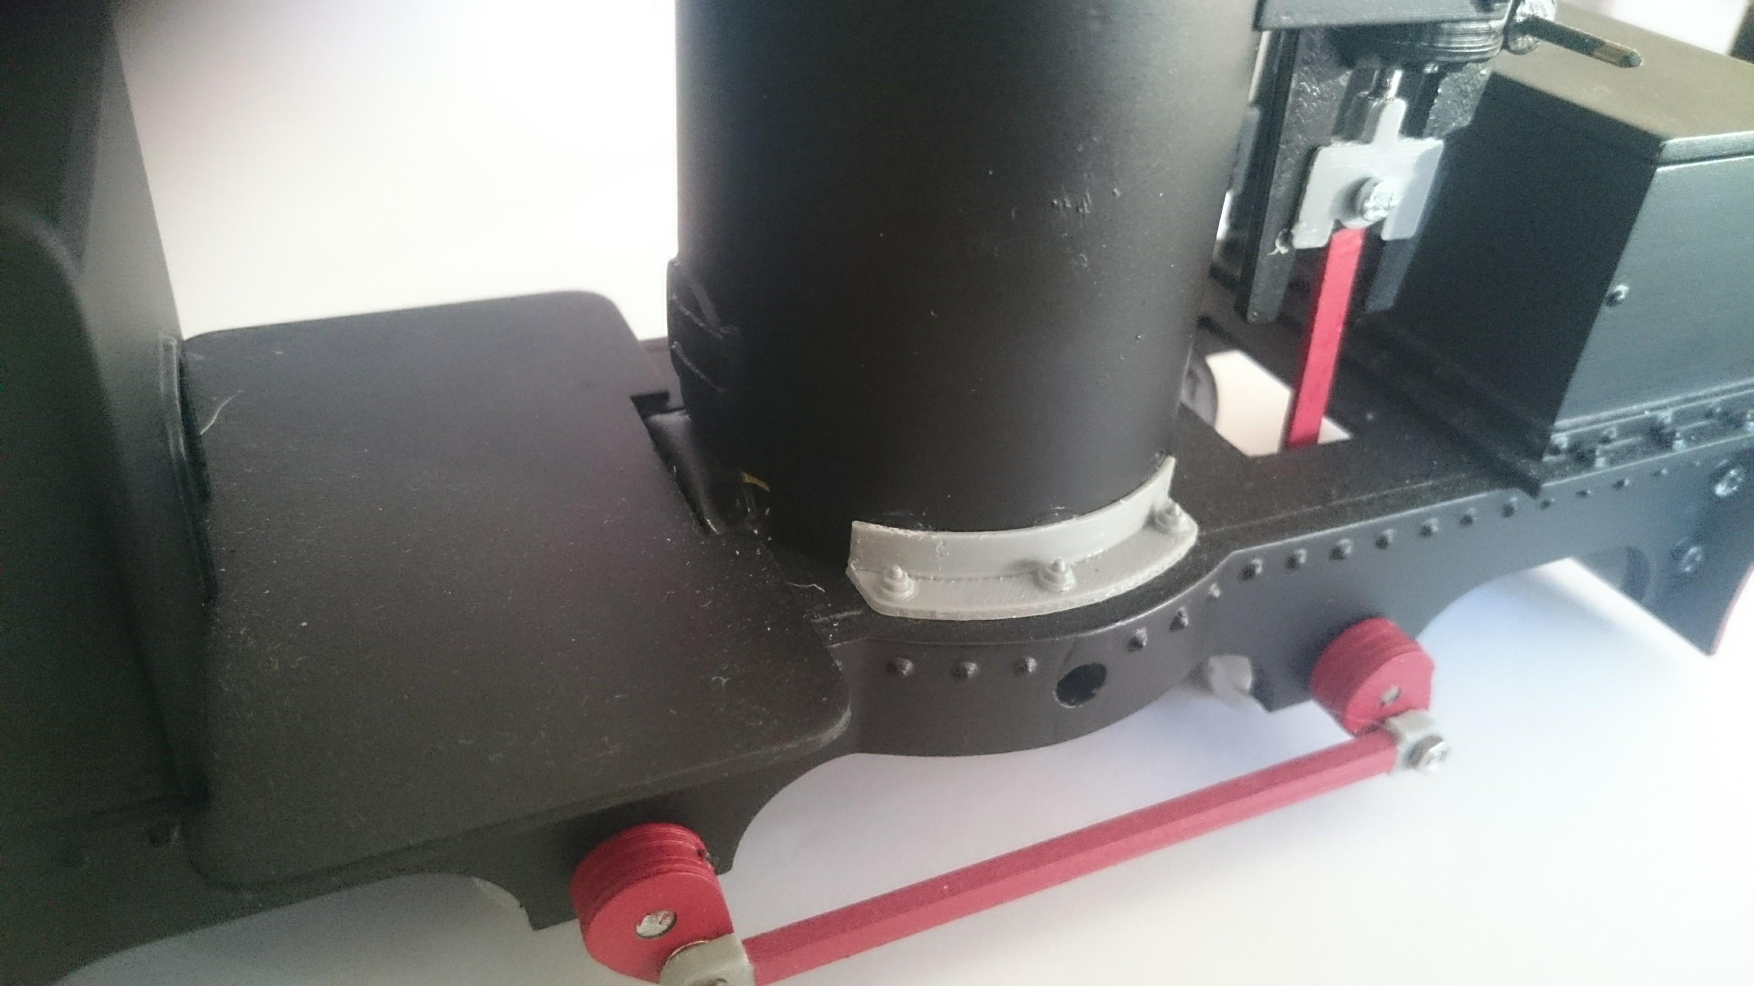
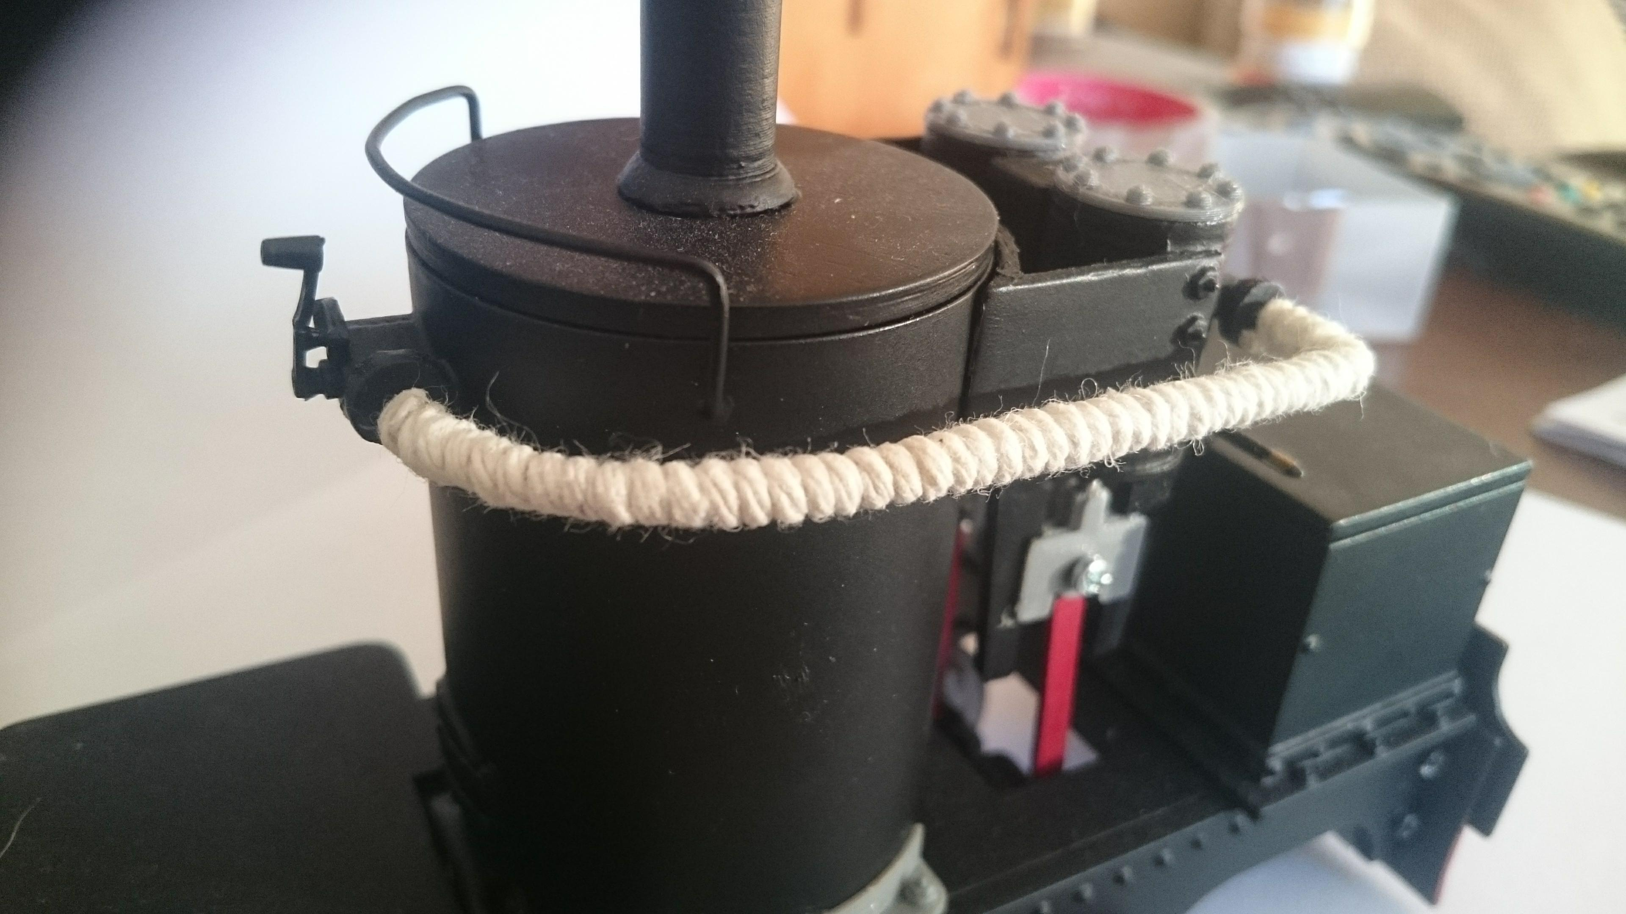

Next drill the reversing and drop link so you can fit 1mm brass wire to join together fit as show
make up the break rod from some brass wire and fit in the coal bunker you can fill the coal with some lead then add coal on top you can add the safety valve parts 2 3mm brass tubes at 20mm long glue on the side of the boiler and fit the 3D printed part on top finish off by adding some more detail part witch are included in the kit

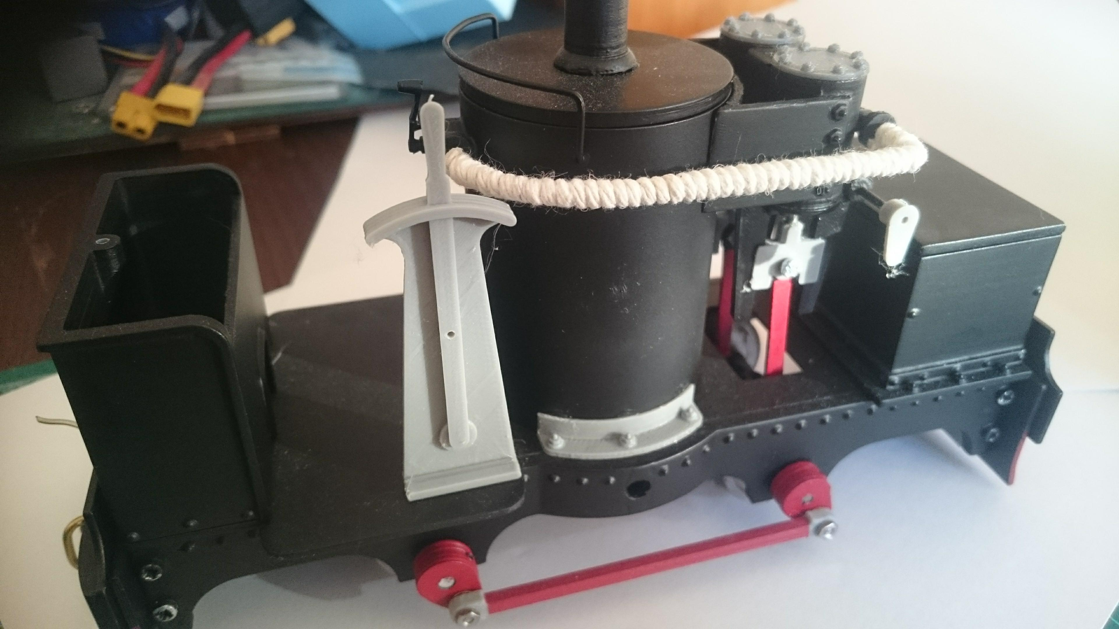
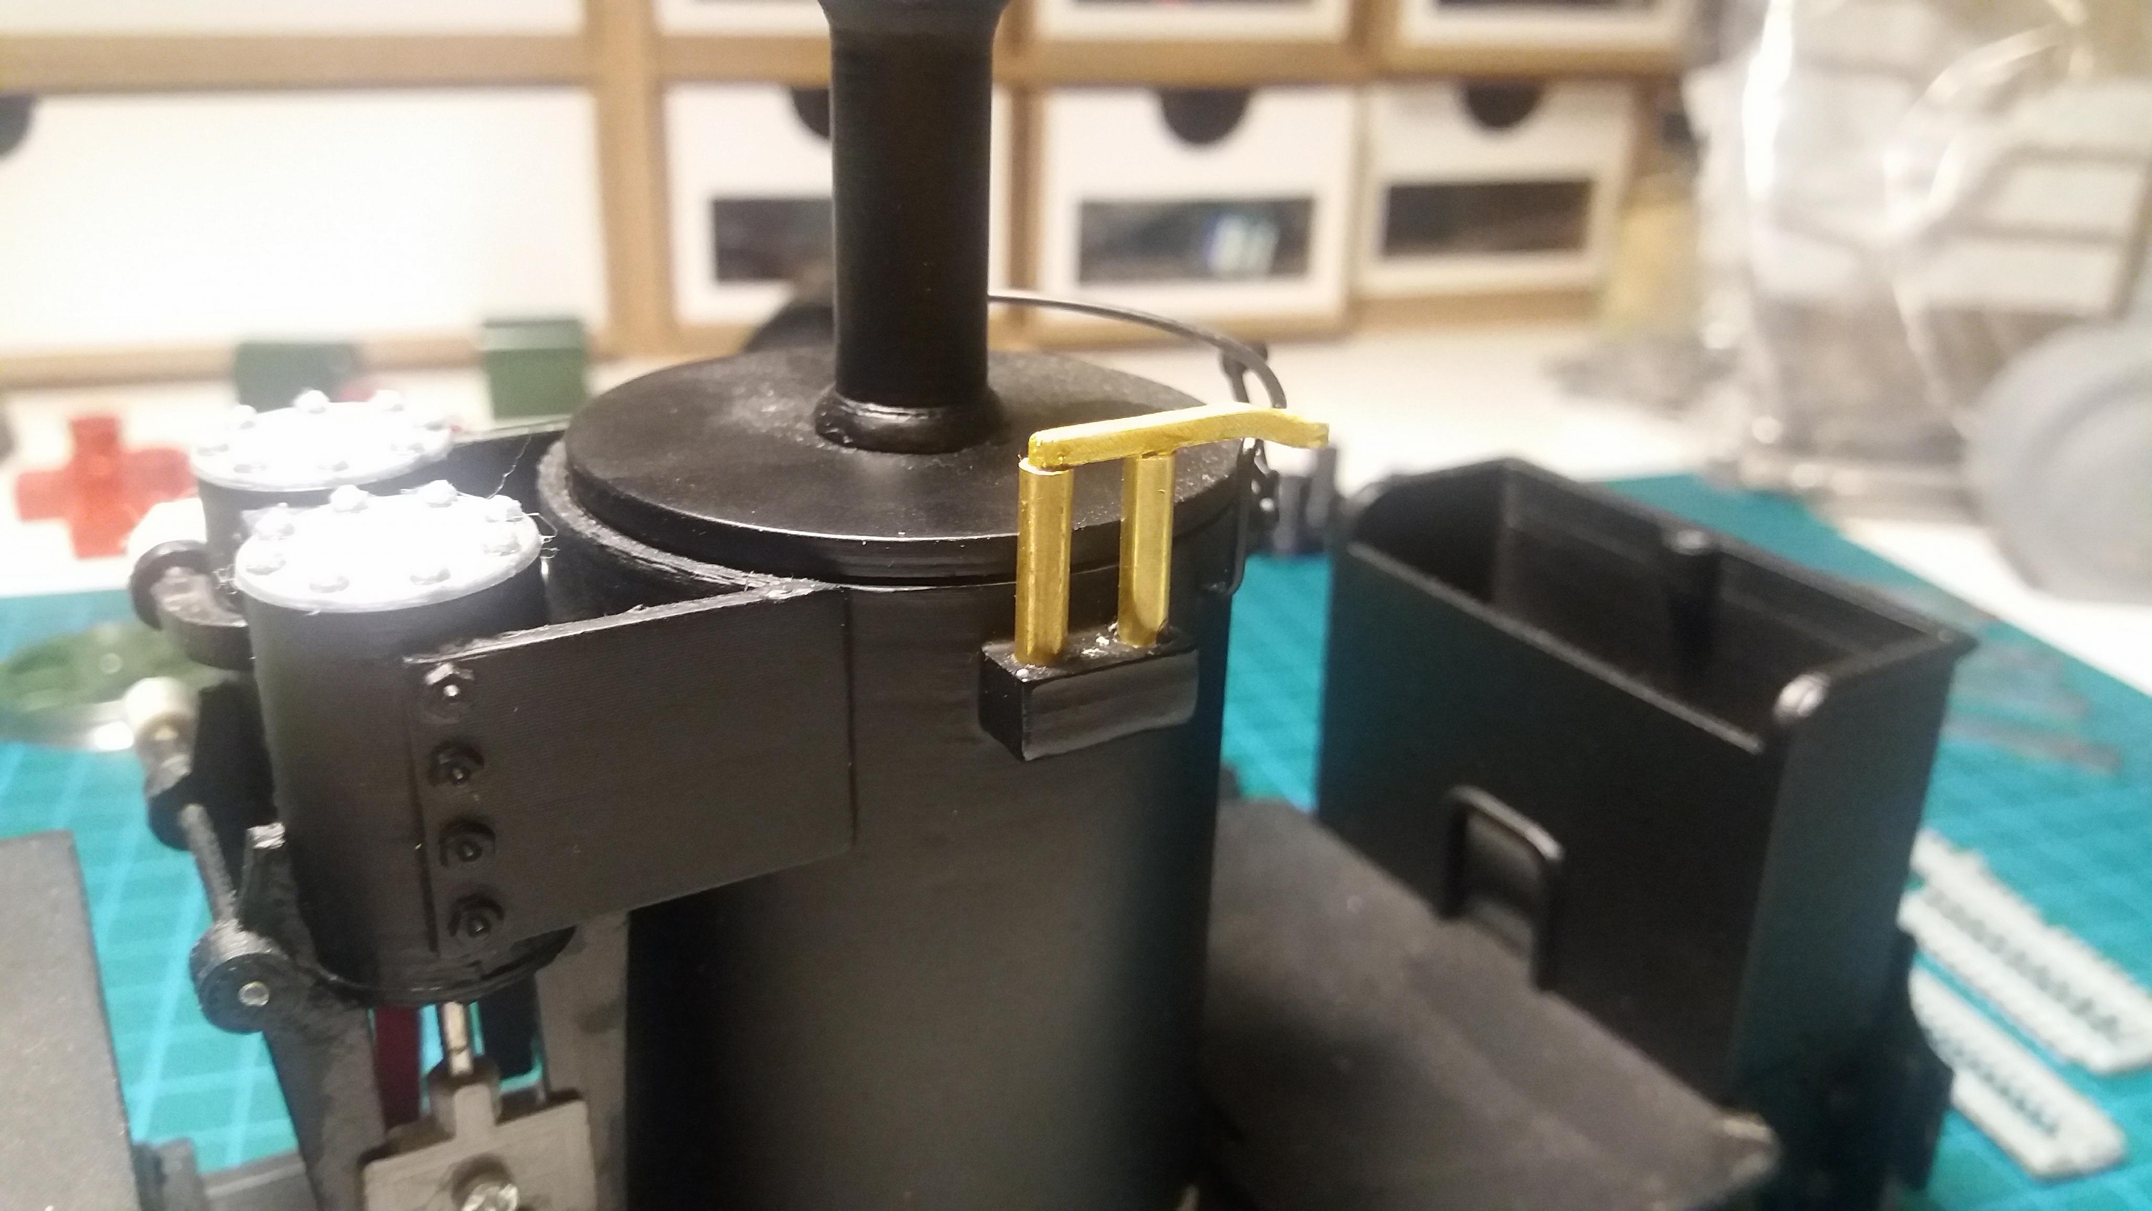

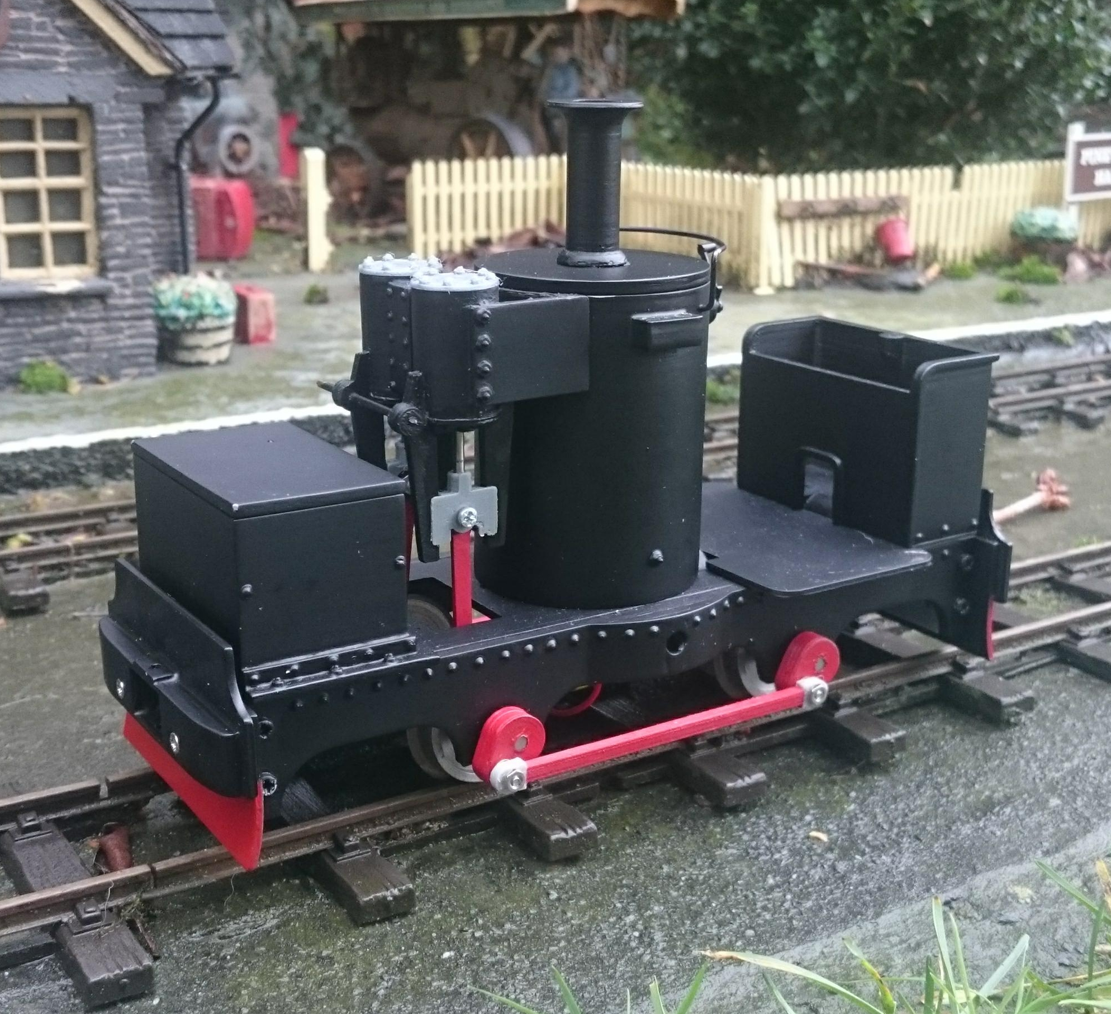

.

I hope you enjoy the kit if you have any questions please email or call us
many thanks leanne and peter
www.pdf-models.com
tel. 07875264075

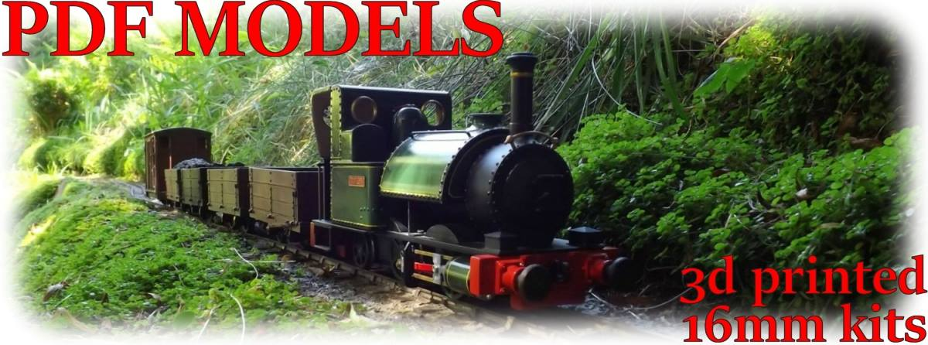

16mm de winton kit
32mm or 45mm gauge

